Please Fill Out This Form

These notes are based on Please Fill Out This Form by Dian D. Chapman
http://www.computorcompanion.com/LPMArticle.asp?ID=22

These notes are based on MS Word 2003

- Create a new blank document File|New… Select Blank Document

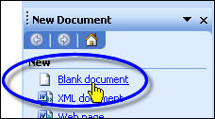

- Save the document as a template File|Save As
- Give the document a File Name eg Form
- Open the Save as type: list
- Select Document Template
- Click Save

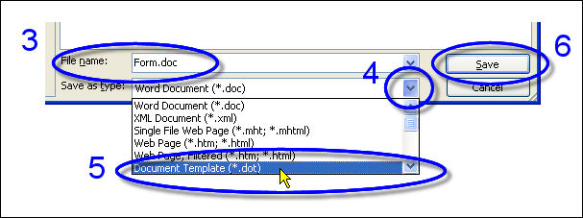

- Turn on the Forms toolbar View|Toolbars|Forms

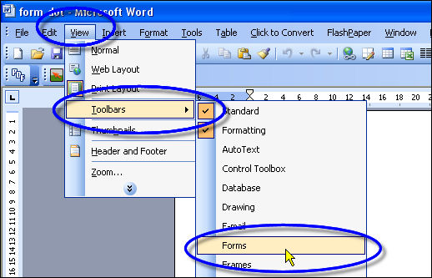

- Type some opening information on the form and then ask the user to enter there name. Rather than adding a line for the name, use a form field. A form field provides a special place for the user's name. Continue adding more information titles such as Address and Phone. After each title, click the Text Form Field button to add a field where the user enters the information. (Be sure to click File|Save to save your work!)

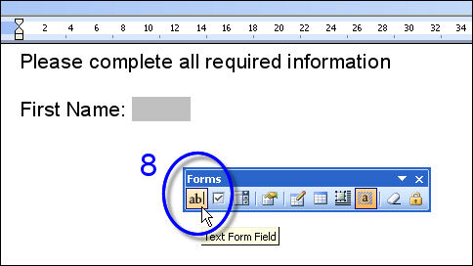

- Add checkboxes
If you have any questions that require the user to check the correct option, you can use the Checkbox field which lets you select an item with a simple mouse click or by hitting the spacebar. If you've ever had to try to enter an X on a form, especially inside some square character someone has created on their own, you'll appreciate this feature!

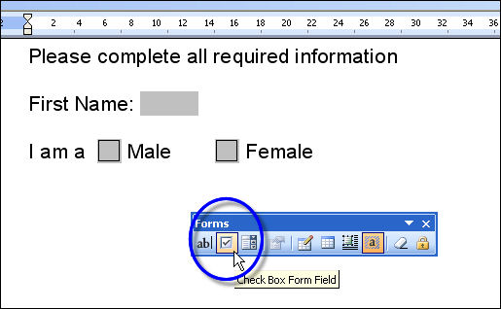

- Add drop-down fields
Another fun feature lets you add a drop-down field. Drop-down fields are used when you want a user to choose, but you don't want them to enter something other than the choices you offer. The user can only choose an answer by selecting one of your options.

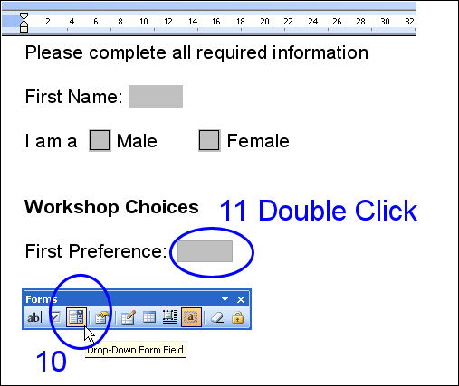

- Double click on the drop down field to edit the list of choices
(up to 25 items).
- Insert your list of items

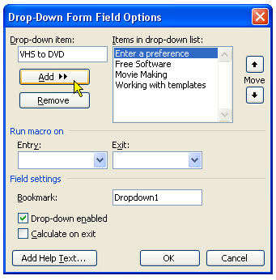

You can Add or Remove items from the list
you can also change the order that items appear in the list using the Move buttons

Note: it is a good idea to make the top entry in the list an instruction to make a selection from the list. That way you will know if the user has simply neglected to make a choice. In this example I have made the top (default) entry Enter a preference

- In this example we want to allow users to make a 2nd and 3rd choice for workshops rather than having to recreate the drop down list again you can simply copy the original drop down field and paste it as many times as you need.
To do this click to the right hand side of the drop down field. Hold down the mouse button and drag to the left then select Edit|Copy or use the keyboard shortcut Ctrl + C. Paste a copy of the drop down field using Edit|Paste or Ctrl + V.

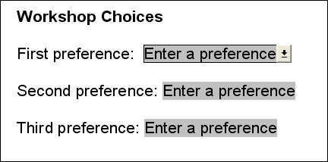

- To test the form you have to Protect the Form. Protecting the form prevents users from changing any of the text in your form. They only can modify text that falls within the fields you've provided. Click the button that looks like a lock in the Forms toolbar.

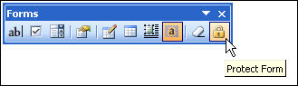

- After testing a form you should Reset Form Fields otherwise when you save the form your test data will be saved with it.

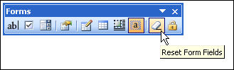

- You may want to know when a form was filled out. To do this enter 2 additional text fields. One for the time and the other for the date.
- Double click on the time field and change the Type: to Current time.
- Double click on the date field and change the Type: to Current date.

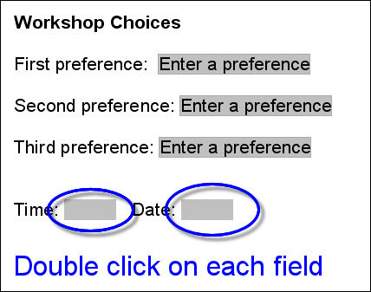

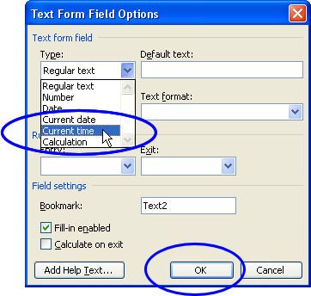

- It is worth experimenting with the settings available in the Current date and Current time Field Options. There are a range of different Time and Date formats available.

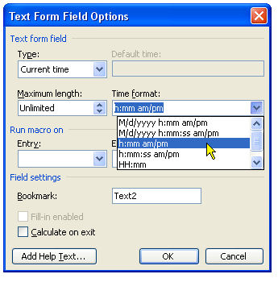

- Before you save your form you should reset the fields and lock the form otherwise users may see your test data and they will be able to enter text outside the forms fields.

- To use this template open a new blank File|New…
- Select Templates on my computer…

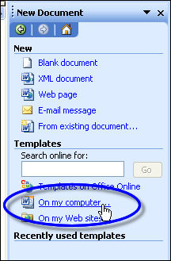

- Select the General Tab and select the template from the list of templates on your computer. Make sure that Create New is set to Document and press OK

