

PowerPoint

This Help sheet will give the basics to be able to produce a simple PPT demonstration.
You need to be aware of the basics of a good presentation – slides should only contain key points – not detail. “Bells and whistles” are fun to add and produce but for the passive viewer they can be an annoyance.

Using PowerPoint in a lecture room or theatre.
The University has several lecture theatres set up with projectors, check the room where you will be giving your presentation to see if you need to borrow a Notebook & Data Projector. Notebook computers & Data Projectors may be borrowed from Media Technology Services basement of the Library. Talk to Pam Goodfellow Ext. 9766 Book well in advance. The School of Education also has a Data Projector & Notebook computer available for staff and student use.

To Start PowerPoint Click the Start Button Then Programs then PowerPoint

Select Blank presentation

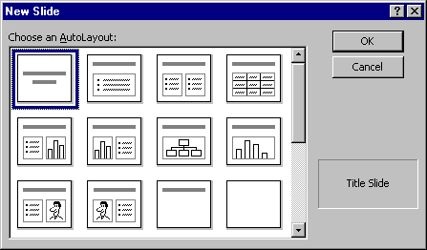

Click on first slide

Type in heading and sub-title
Select ‘New slide’ from top tool bar

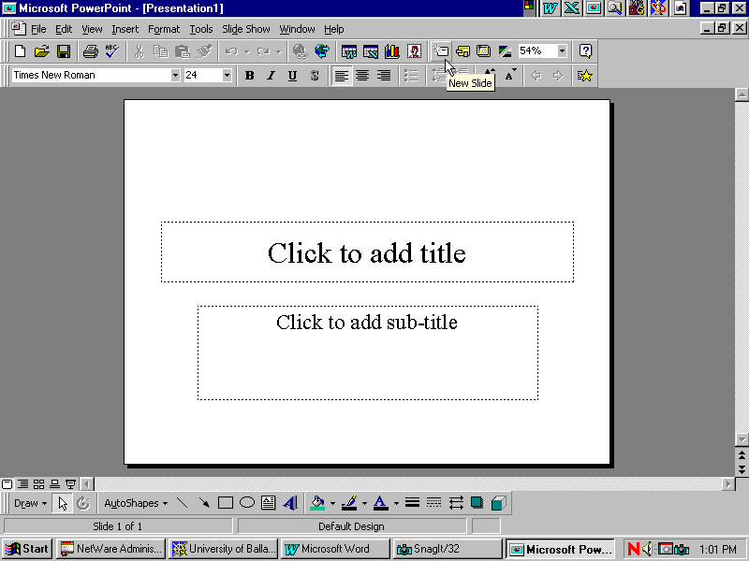

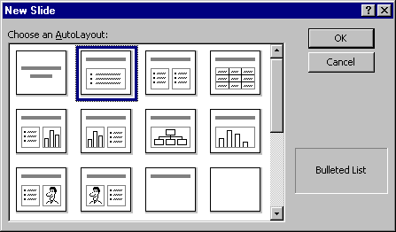
Select second slide option (Heading and bullet list)
Type heading and 3 bullet points

Save your work at this point

Select – File | Save as
Save to the J:\ drive not the C:\ drive. Work saved to C:\ on the student network will be lost when you log off. Save regularly. Especially before viewing the presentation. It is best to save using incremental file names. E.g. save your first version as presentation1a.ppt and at the end of the session use File | Save As… to save a new version called presentation1b.ppt. If your latest version becomes corrupted you can keep working with the backup version.

When you have completed the presentation delete all the incremental versions.

This may seem like a lot of work but it will save you from having to start from scratch should your file become corrupted.

Click on New Slide
Select one of the image/bullet slides from the 3rd row
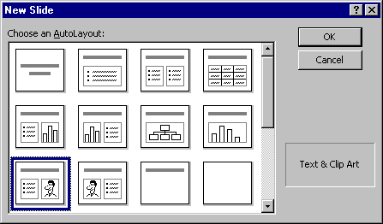
Fill in heading and bullets then double click on image
Choose any image from Clip Art – insert
Possible to enlarge or move image using toggle bars.

Click on New Slide
Select slide with heading and blank space
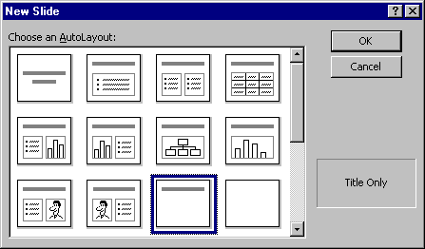
Give slide a heading
Minimise PowerPoint (click on – symbol top RH side of screen)
Open Netscape Communicator from desktop
Go to ( http://www.zoo.org.au )
Select Melbourne Zoo
Select an animal from ‘Animals at the Melbourne Zoo’
Point over photo of animal
Right click mouse
Select 'Save image as'
Save to a temp. file
Image should default to be saved as a JPG file
Close Netscape
Maximise PowerPoint
Return to slide currently creating
Click outside Heading area
Select Insert from toolbar
Select: Picture/From file/choose file that was just created/Insert
This should paste the Internet image onto the slide.

Use Double arrow key on scroll bar to return to first slide
Changing font size and colour
Highlight Headline (Point and drag with mouse)
Select Format from top toolbar
Click on Font
Click on arrow in box below ‘Colour’
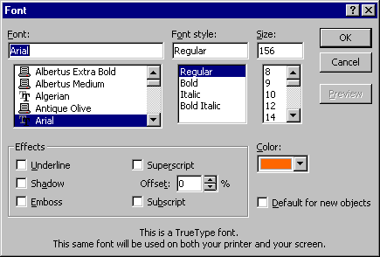

Select ‘More colours’
Select own colour scheme
Return to Slide view
Highlight headline again
From top toolbar Click on A^ to increase font size
Alternatively A to decrease font size

From bottom PowerPoint toolbar (Left Hand side of screen) select the slide sorter view button (4 little squares).
Click on slide number 4
Hold down the left mouse button and drag this slide in between slides 2 & 3
This is how to reorder slides
While still in Slide sorter view click on Format from top toolbar Select Apply Design Template
Select a design
Click on Apply
Adding transitions
From top PowerPoint toolbar
Select Slide Show
Select Slide Transition
This brings up an option box
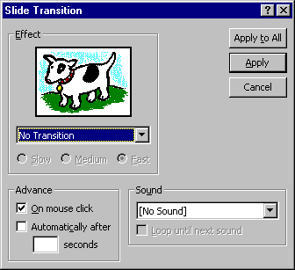
Suggest select SLOW
Sound – some lab computers have sound cards, while in 'slide transition' select a sound for each slide (this is just fun)
Select Apply to apply transition to individual slides
Work through each slide adding a transition to each.

Select slide with bullet list
Highlight bullet points
From top PowerPoint toolbar select ‘Slide show’
Select Preset animation
Select effects for bullet transition ie 'wipe from right'
Click on 'Apply'

Spell check
Select Tools from top PPT toolbar
Click on Spelling
*This step is important – spelling mistakes stick out like a sore thumb and detract from a presentation.

Running the slideshow
Use the Slide Show | View Show
Or press the F5 key.

Select Slide Show from bottom PPT toolbar (Little projector screen)
The slide show will now run as it would appear through a projector. Each click of the mouse will bring on a new slide.

Printing
Select ^P (control p) to bring up the print menu
From bottom of print box click on arrow next to ‘Print what ‘box
Highlight Handouts – 3 per page
This is the best print option for reviewing slides
Click on OK

- This is a very brief guide, to create more detailed presentations use the Help key or refer to a PowerPoint manual available from the library.

- Remember preparation will ensure success, we recommend you rehearse your presentation in full, using the same equipment that you intend using for the actual presentation.

