The MStar* (Thanks to mstar.org.uk for the inspiration) Effect my version of which is
viewable on my home page http://www.ballarat.edu.au/~rrussell
was created by hand in 20 minutes using in my case JASC Paint Shop Pro and Animation Shop (http://www.jasc.com).

The effect is created by starting with a normal digital photograph. The original photograph needs to be at least 640 x 480 pixels.

The image is resized to reduce file size prior to creating the animation.



A layer is added to the photograph
This can be done using any drawing program that supports layers eg Paint Shop Pro, Adobe Photoshop, Macromedia Flash, and many others.

On the layer you draw a very rough copy of the person in a “cartoon style”.
(Any style could be used but it is best to keep detail to a minimum unless you want the process to take hours at this point.)

The first time I had a go at this process I put in far too much detail into the drawing on the layer, in this case less is more.

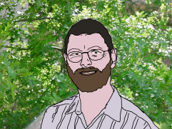

Start by drawing the outline using a thick brush coloured black.
You want to create areas that can be filled using a solid colour so don’t leave gaps in the outline.

I started by outlining my shirt and then worked upwards outlining my beard and lips then jumped to my hair and then last of all worked on the detail in the face.

Don’t get carried away in attempting to duplicate every little detail what you want is just the essential elements.

Having drawn the outlines you then pick a representative colour from within each area and use it to fill that area.

When you are happy with the “cartoon drawing” you then create an animation that blends the original photograph with the layer progressing from a100% layer transparency to a 0% layer transparency.

In my case I did this using Paint Shop Pro and created each of eleven frames. In each frame I reduced the transparency of the “cartoon” layer by 10%.

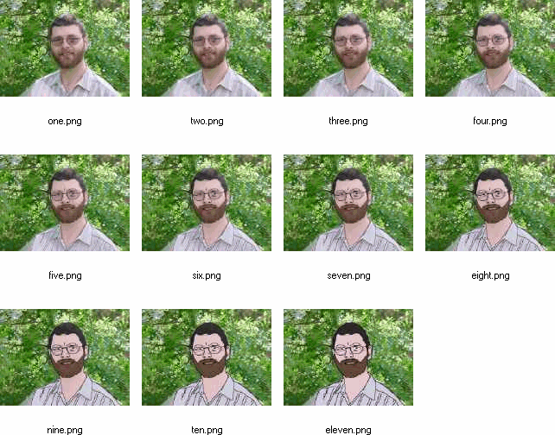

I then used Animation shop to create an animated GIF

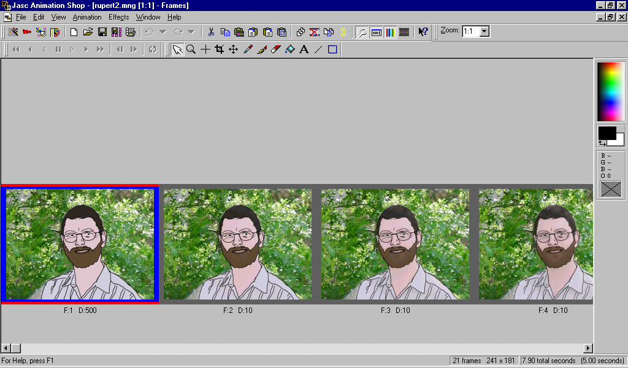

See my notes on Animation Shop for some detail on this process.

Note that the final animation sequence starts in my case with the first frame showing no transparency on the cartoon layer and moves to 100% transparency and the back to 0% transparency.

I did this by putting each frame in order then selecting all the 11 frames and copying them onto the end of the animation sequence.

Then I reversed the order of the frames.

Last of all I changed the timing of the first frame to 500/100’s of a second to add a 5 second delay before the animation fades to “normal” and then back to cartoon again.

The guy who produced the Mstar* Web Site said that he used Flash.

I have not worked enough with Flash to figure out how to automatically create a tween that will fade the layer from 100% to 0% and back over time.

If I knew how to do that then the tedious process of manually creating each frame and stitching them together in Animation Shop could be avoided altogether.

If you know how to do this can you tell me. It’s on my to find out list…

The reason I used Paint Shop Pro and Animation Shop is simply because I knew how to use them and figured that it would take me more than 20 mins to work out how to use Flash and I wanted a quick result.

P.S. If you want to automate the drawing stage then you can use one or more artistic effects provided by programs like Paint Shop Pro.

See Below:

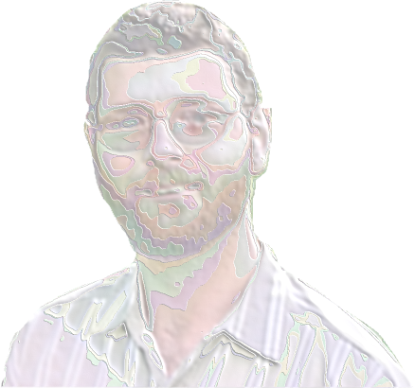

This is a combination of Enamel and Brush Strokes. With background removed.

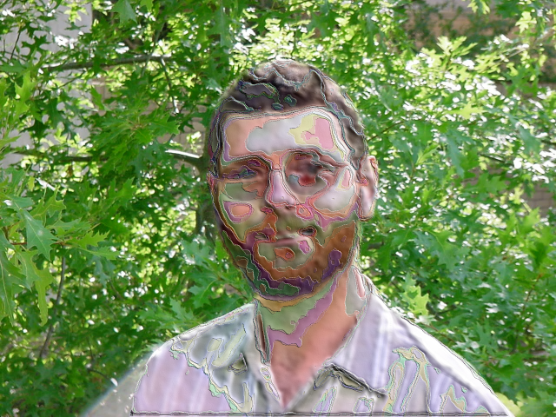

As above but with the background visible.

To do this in Paint Shop Pro is very quick and easy when you know how…

Use the Freehand lasso tool to outline the portion of the picture you want to apply the effect to.
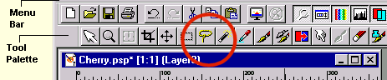

Then copy it and paste it as a new layer.

Edit | Paste | As new Layer or use CTRL + L

Turn on the Layers Pallet

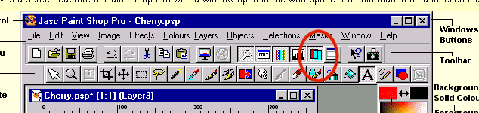

Select the new Layer

Then pick the effect you want to play with from

Effects | Artistic Effects

I chose Enamel and then created a second layer and applied Brush Strokes
Play around with different settings of Stroke Length and Brush Width etc to find the effect you want.

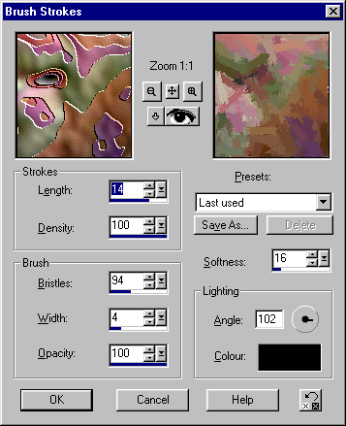

Once you have applied the effect you want to the layer you then merge the layers

Layers | Merge | Merge All (Flatten)

Copy the image and paste it as a frame into Animation Shop
Then switch back to Paint Shop Pro and undo the Merge All (Flatten) and change the transparency of the layers to create the next frame in the animation sequence.

It’s important to merge the layers before you copy the picture otherwise you end up just copying the layer and not the background as well.

