Advanced Game Maker
Tony Forster Aug 07 for GameMaker version 6.1

May be copied or modified with acknowledgement of authorship

Tony Forster http://www.schoolgamemaker.rupert.id.au/

23/7/07

Variables 2
Execute a piece of code 2
Setting and testing variables 2
Common variables 3
Scope and visibility 4
Persistence 5
Sprites and Drawing 6
Steering a car 6
The clock 8
Individual health bars 9
Entering Data 10
Miscellaneous 10
Random 10
With 11
Self, other, all, instance 11
What do these do? Try them 11
More reading 12
Gamemaker Code – self paced tutorial 12
Getting started 13
Making Teddy Move 13
Something to shoot at 16
OK Lets Shoot!! 19
Kill Ghosts 21
Links 24
Resources 24
Forum 24
Kids work 24
Book 25

Variables

Execute a piece of code
Rather than drag and drop actions, you can use the more powerful code. The “execute a piece of code” action looks like this:

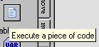

You can type code into this window or paste to it from help or elsewhere. Note how the colour changes when Gamemaker recognises something, for example:

if(mouse_x<200 && mouse_y<200) window_set_cursor(cr_hourglass) else window_set_cursor (cr_default)

light blue for variables
dark blue for functions
red for constants
magenta for objects
green for comments
bold for language words

If you don’t get the colour you expect, you have made a typing error

Try this,
new game
add an object
add event step
execute a piece of code
if(mouse_x<200 && mouse_y<200) window_set_cursor(cr_hourglass) else window_set_cursor (cr_default)
new room
place object in room
run

Setting and testing variables
You can use code fragments in “set the value of a variable”
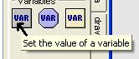

and test with “if a variable has a value” or “if an expression is true”
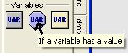 or 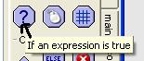

Common variables
x Is an object’s x-position.
y Is an object’s y-position.

Example:
new game
new sprite
new object
set the sprite for the object
add event keypress<space>
set the value of a variable
x=100
y=100

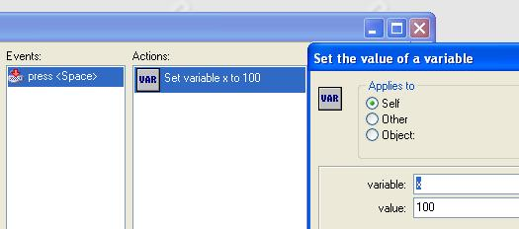
new room
place object in room
run
it jumps to position 100 100 when you press space

hspeed Horizontal component of the speed.

Example
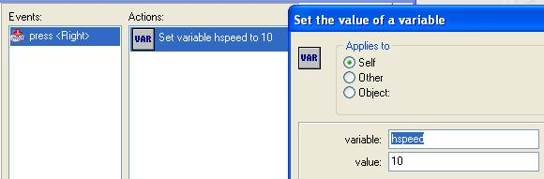

In the keypress<right> event
hspeed =10 move to the right speed 10 when you press right cursor

vspeed Vertical component of the speed.

direction Its current direction (0-360, counter-clockwise, 0 = to the right).

speed Its current speed (pixels per step).

mouse_x X-coordinate of the mouse.
mouse_y Y-coordinate of the mouse.

Example:
In the step event
x= mouse_x
y= mouse_y the object moves with the mouse

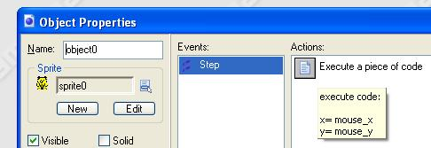

Scope and visibility
There are some reserved names
mouse_x
mouse_y
health
score
lives
room_width
room_height
which are global

most variables belong to the object within which they are defined

there is also the global object global eg global.x

So for code within object0 , x is the horizontal position
to refer to it from inside another object use object0.x (is the x value or horizontal position of object0)

See http://www.schoolgamemaker.rupert.id.au/samples1/inventory.gm6
The object "inventory" is used to keep track of diamonds, the variable "diamonds" is the number of diamonds collected
Create Event:
set variable diamonds to 0

When you collide with the diamond it is destroyed and the inventory count increases by 1
Collision Event with object object1:
set variable inventory.diamonds relative to 1
for other object: destroy the instance
diamonds lives inside the inventory object, when referred to inside inventory, you can just call it diamonds, when referred from another object, you must use the full name inventory.diamonds

In the draw event for inventory, a box and the collected diamonds are drawn
Draw Event:
set the fill color to 16777215 and line color to 0
draw rectangle with vertices (0,0) and (200,40)
A white box is drawn

set variable i to 0
repeat next action (block) diamonds times
at position (20*i,0) draw image -1 of sprite sprite1
set variable i relative to 1
The sprite is drawn "diamonds" times
i is increased each time it is drawn, it is drawn further to the right each time as i increases

Persistence
Objects and rooms can be persistent
Normally objects and rooms are created fresh every time
See http://www.schoolgamemaker.rupert.id.au/samples2/persistent.gmd
The balls in room 0 stay where left
in room 1 they revert to original positions

See http://www.schoolgamemaker.rupert.id.au/samples2/persistentobject.gmd
Move the dog with the mouse
When the dog walks through paint, it is that colour in all rooms
Turn off persistent for the dog and it starts anew in each room

Sprites and Drawing

Steering a car
We will rotate a car using its inbuilt variable “direction”

Add a sprite
edit sprite
double click image0
zoom in with magnifying glass

Draw a car facing left
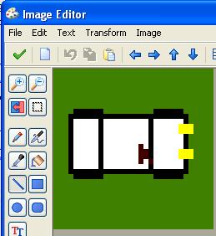

Note the colour of the bottom left pixel becomes transparent

To draw this at 10 degree rotation,
close with the green tick
animation|rotation sequence|counterclockwise

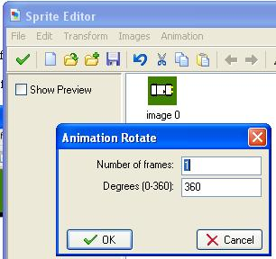

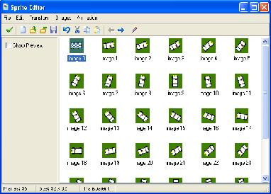

now add an object and room
put the object in the room
in the object’s step event
move in the direction of a point mouse_x, mouse_y at speed 1
change the sprite, sprite0, subimage direction/10

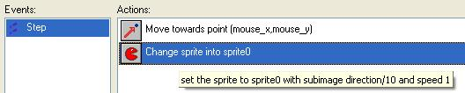

Now we will display some text
Delete the change sprite in the step event
Instead use draw sprite in the draw event

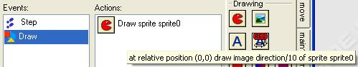

It should work the same

Add a font, (Arial 12 is OK)
In the draw event,
set the font to font0
Draw a text: ""+string(direction), 0,20 relative

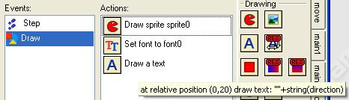

The clock
Add object
Add room
Room properties, settings 400x400
Place object in room
Draw event, execute a piece of code
draw_circle(200,200,130,true) see help game graphics, drawing shapes
Run it, that’s the circle

minuteangle=2*pi*current_second/60
x2=200+100*sin(minuteangle)
y2=200-100*cos(minuteangle)

x2,y2 is the tip of the second hand and 200,200 the centre
draw_line(200,200,x2,y2)

Now repeat for minute and hour, a little shorter
you will need current_minute and current_hour which are in help under gameplay, timing
Add the hour marks
for(i=0; i<12; i+=1)
{
x1=200+110*sin(2*pi*(i)/12)
y1=200-110*cos(2*pi*(i)/12)
x2=200+125*sin(2*pi*(i)/12)
y2=200-125*cos(2*pi*(i)/12)
draw_line(x1,y1,x2,y2)
}
Completed clock at http://www.schoolgamemaker.rupert.id.au/samples4/clock6.gm6

Add the day and date, maybe even an alarm

Individual health bars
There is a global variable, “health” and you can draw the health for one object
New sprite
new object
new room
place object in room
draw event, draw a sprite, sprite0 0,0 relative

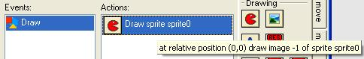

from the score tab, draw the health bar, -20,30,20,40 relative

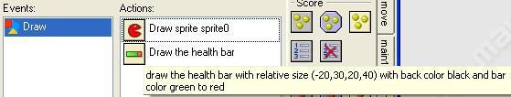

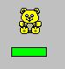

But health is global and you can’t have instances with different health, test this with multiple instances and eg mouse click reducing health

Delete: draw a health bar
create event, set the value of a variable, energy ,30
draw event
set the colour to green
draw rectangle –20,30,-20+energy,40, filled, relative (this is the energy)
set the colour to black
draw rectangle –20,30,20,40, outline, relative (this is the outline)

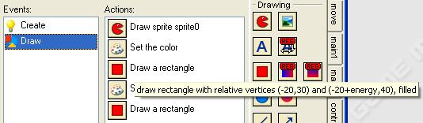

test this with multiple instances with differing energy

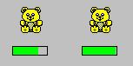

See http://www.schoolgamemaker.rupert.id.au/samples1/healthbar.gm6

Tony Forster http://www.schoolgamemaker.rupert.id.au/ July 07

Entering Data
See http://www.schoolgamemaker.rupert.id.au/samples1/questions.gmd
One drag and drop item
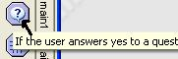

The rest are code
result = show_menu('menu0|menu1|menu2',0)
show_message('menu '+string(result)+' selected')
if(show_question('yes or no')=1)
show_message('you said yes')
else
show_message('you said no')
show_message('squared is' + string(sqr(get_integer('enter a number',0))))
show_message('you entered:' +get_string('enter text','no string'))
show_message('colour number '+string(get_color(0)))

Miscellaneous

Random
random(x)
random(x) Returns a random real number between 0 and x. The number is always smaller than x.

With
In addition to the usual
if (<expression>) <statement>
repeat (<expression>) <statement>
while (<expression>) <statement>
do <statement> until(<expression>)
for (<statement1> ; <expression> ;<statement2>) <statement3>

there is the with construction
with (object) <statement> repeats statement for all instances of object

Self, other, all, instance
self // the object containing the code
other // the other object in the collision
all // all instances of all objects in the room
object0 // all instances of object0 in the room

What do these do? Try them
(You can paste these from this document directly into the “execute a piece of code” window)

In the step event:
if(mouse_x<200 && mouse_y<200) window_set_cursor(cr_hourglass) else window_set_cursor (cr_default)

in a keypress event
for (i=0 ; i<10 ; i=i+1) instance_create(x+10*i,y+10*i,object0)

What’s the difference between
with (object0) instance_destroy() and instance_destroy()
when placed in object0’s code? in another object’s code

In a keypress event:
instance_create(random(400),random(400),object0)

In the step event:
if (x<0) hspeed=5
if (x>300) hspeed=-5

try this in the draw event:
draw_sprite(sprite0,-1,x-5,y)
draw_sprite(sprite1,-1,x+5,y)

instance_create
instance_create (x,y,obj) Creates an instance of obj at position (x,y).
Example:
In a keypress<space> event
instance_create (100,100,object0) create an object0 at position 100 100 of the screen

instance_change
instance_change (obj,perf) Changes the instance into obj. perf indicates whether to perform the destroy and creation events.
Example:
instance_change (object0,false) change into object0 without performing the destroy and creation events

More reading
Go to gamemaker help contents and look at The Gamemaker Language, there are heaps of useful things there.

Gamemaker Code – self paced tutorial

Getting started
Just like any other Gamemaker game, you will need a sprite
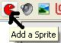

I’ll choose the teddy


You will need an object
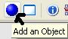

You need to assign the sprite to the object
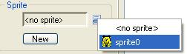

You need a room
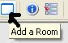

You need to put the teddy in the room
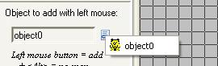

Making Teddy Move
OK so far its all been the same as what we’ve done with drag and drop. Now we’ll make teddy move with the arrow keys but we’ll use code.

Add event keyboard left
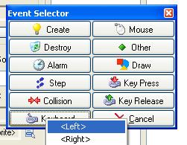

Drag an “Execute a piece of code” action into the action window
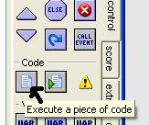

See how a window opens up
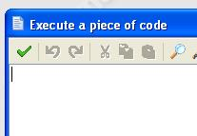

When we hit keyboard left we want teddy to move left, we want to set the horizontal speed to a negative value because in Gamemaker, positive is too the right. There’s an inbuilt variable for every object, the horizontal component of speed hspeed.

How did I know that? Its in the help.
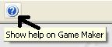

All the code stuff is at the end under Game Maker Language (GML)
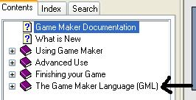

I found about hspeed in Gameplay – Moving around
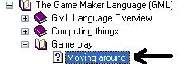

hspeed Horizontal component of the speed

Lets make hspeed –5
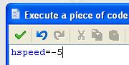

Note how hspeed is in blue, Gamemaker recognised it as a variable

Just like hspeed is the horizontal component of speed, vspeed is the vertical component.
Now add event keyboard right, make hspeed =5
add event keyboard up make vspeed =–5
add event keyboard down make vspeed =5

See how we can move teddy with the cursor keys. Now I want teddy to stop when I’m not pressing a key.
Add event keyboard no key
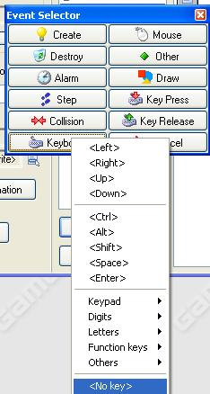

And drag in the “execute a piece of code” action

Now I could type
vspeed=0
hspeed=0

but I read the help and noticed another variable speed so I’ll just type
speed=0

Ok it works. What next?

Something to shoot at
Shooting is not ‘politically correct’. Big problem. Ghosts don’t have rights. Lets shoot ghosts.

Like before get a new sprite


Get a new object, assign the sprite to the object and put the object in the room
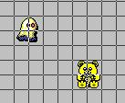

Ok, we want the ghost to move in a random direction
Add a create event for the ghost
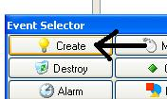

Drag an “Execute a piece of code” action into the action window
We’ll give the ghost a fixed speed but a random direction
speed=5
direction=random(360)

How did I know about the variables speed and direction?
Found them same place as vspeed and hspeed

How did I know about the function random

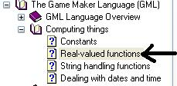

random(x) Returns a random real number between 0 and x. The number is always smaller than x

Lets keep the ghost in the room by making it wrap
Add event other / outside room
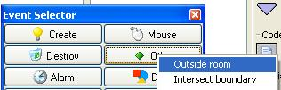

Add this code to make it wrap
move_wrap(true,true,0)

Where did move_wrap(true,true,0) come from?

move_wrap(hor,vert,margin) Wraps the instance when it has left the room to the other side. hor indicates whether to wrap horizontally and vert indicates whether to wrap vertically. margin indicates how far the origin of the instance must be outside the room before the wrap happens. So it is a margin around the room. You typically use this function in the Outside event.

Note how true is red, it is a pre-defined constant

OK Lets Shoot!!

We need a sprite for our bullet, an object for our bullet and we need to assign the sprite to the object. Do it. The bullet should be object2

Now, we’ll shoot bullets from the teddy when we press space
For object TEDDY add event keyboard space
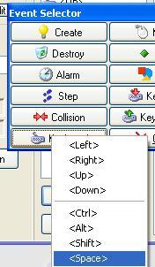

And add the following code
instance_create(x,y,object2)

(I’m assuming that object2 is your bullet too)
Because we are inside the teddy object, x and y refer to the position of the teddy so the bullet appears where the teddy is, position x,y

Where did instance_create(x,y,object2) come from?

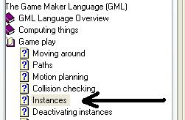

instance_create(x,y,obj) Creates an instance of obj at position (x,y). The function returns the id of the new instance

Small problem, the bullet doesn’t move
For the bullet, add event create

speed=10
direction=object0.direction

The bullets are created with speed=10 and their direction is set to the same direction as the teddy

What’s the dot all about?
In direction=object0.direction the dot “.” is important
If we are inside an object, x, y , vspeed, hspeed etc refer to that object, if we want to refer to other objects we use the dot

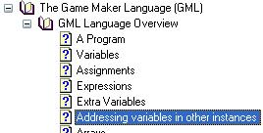

Kill Ghosts
Ok when the bullet collides with the ghost we destroy the ghost. Easy.

For object ghost add the collision event with the bullet
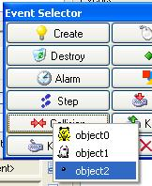

And add the following code
instance_destroy()

Where did instance_destroy() come from?

In case its not working for you, here’s the pseudo code for my program. You can display pseudo code with alt / edit / show object information
My teddy is object0, ghost object1 and bullet object2

Information about object: object0

Sprite: sprite0
Solid: false
Visible: true
Depth: 0
Persistent: false
Parent: <no parent>
Mask: <same as sprite>

Keyboard Event for <no key> Key:
execute code:

speed=0

Keyboard Event for <Space> Key:
execute code:

instance_create(x,y,object2)

Keyboard Event for <Left> Key:
execute code:

hspeed=-5

Keyboard Event for <Up> Key:
execute code:

vspeed=-5

Keyboard Event for <Right> Key:
execute code:

hspeed=5

Keyboard Event for <Down> Key:
execute code:

vspeed=5
______________________________________________________

Information about object: object1

Sprite: sprite1
Solid: false
Visible: true
Depth: 0
Persistent: false
Parent: <no parent>
Mask: <same as sprite>

Create Event:
execute code:

speed=5
direction=random(360)

Collision Event with object object2:
execute code:

instance_destroy()

Other Event: Outside Room:
execute code:

move_wrap(true,true,0)

______________________________________________________

Information about object: object2

Sprite: sprite2
Solid: false
Visible: true
Depth: 0
Persistent: false
Parent: <no parent>
Mask: <same as sprite>

Create Event:
execute code:

speed=10
direction=object0.direction

______________________________________________________

Total for the above, 10 marks

Add a sound when you shoot 1 mark
Hint:
You’ll find sound_play(sound0) at
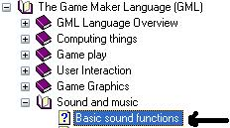

When you shoot all ghosts, go to the next room 1 mark
Hint:
Use if , instance_number() and room_goto_next()

Make homing missiles 1 mark
Hint:
move_towards_point()

Show the score 1 mark

Show a dialogue box congratulating you when you have won the game
1 mark

Show the help screen when you first start the game 1 mark

When you shoot the ghost boss, have 10 ghosts spawn at random places which you then have to shoot 1 mark
Hint:
Use repeat () random()and instance_create()

In the above, instead of using repeat () use for()
1 mark

In the above, instead of using repeat () use do
1 mark

In the above, instead of using repeat () use while()
1 mark

Links

Resources
http://www.schoolgamemaker.rupert.id.au/
http://beam.to/billkerr
http://www.mindtools.tased.edu.au/gamemaker
www.gamemaker.nl

Forum
http://www.groups.edna.edu.au/course/view.php?id=81

Kids work
http://www.schoolgamemaker.rupert.id.au/computerclub/index.html , Gamemaker year 1 to 8
http://etrain.pbwiki.com/ Gamemaker, years 5 & 6
http://ahefner.com/game.html The Hefner Hideout, Gamemaker games
http://www.nhavenr7.sa.edu.au/students.htm games made by 6/7 students using Gamemaker
http://www.newtown.tased.edu.au/computingweb/gamemaker/examples.htm Newtown High School, Tasmania Australia, Gamemaker
http://alupton.wordpress.com/learning/game-maker/ A dual purpose educational site. It helps serve the communication and collaboration needs of an Australian Year 3 class. It is also an exploration and demonstration to help cater for the needs of other primary school classes
http://www2.osc.lk/eye/Student%20gallery/gamemaker.htm Gamemaker games from The Overseas School of Colombo
http://www.epcds.org/Student%20section/Game_Maker/gamemaker_games.htm Gamemaker games from El Paso Country Day School (K-12)
http://www.nexusresearchgroup.com/info_systems/games.htm students from Inglewood High School and New Plymouth Girls' High have been taught to create games that are fun to play while learning about programming, logic and graphics design.
http://www.cse.ohio-state.edu/~bbair/WIC/games4girls/ a workshop for 2006 Women in Science day, called "Computer Games for Girls". Seventeen girls, ages 13-14, attended the workshop
http://www.cse.ucsc.edu/classes/cmps080k/Winter06/games.html final student projects in the course, Foundations of Interactive Game Design, taught at the Univ. of California, Santa Cruz, in Winter quarter 2006
http://ontrack.ncsu.edu/SummerCamp/2005/Games/Students/ Index of /SummerCamp/2005/Games/Students
http://www.dakabinshs.qld.edu.au/Student_Activities/GMfromK/maze.htm A group of students from Kurwongbah State School traveled to Dakabin High School to use the computer program Game Maker to design and make our own computer games

Book
http://www.amazon.com/Game-Makers-Apprentice-Development-Beginners/dp/1590596153

