Expanding GameMaker with scripting
Tony Forster June 07

Though GameMaker can do lots of things with drag and drop you occasionally want extra features that require scripting.

The good stuff is on the “control” tab.

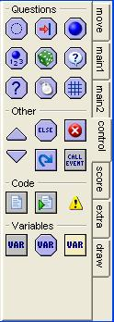

You can set a variable with
and test it with
or

For more complicated things, the “execute a piece of code” action looks like this:

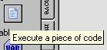

You can get help on what things you can do at

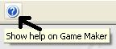

All the code stuff is at the end under Game Maker Language (GML)
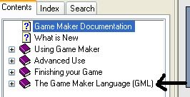

Examples
Healthbar http://www.schoolgamemaker.rupert.id.au/howto.htm
You want to draw healthbars under a number of characters, Game Maker’s inbuilt draw the health only allows you to draw one character’s health. This shows how to draw multiple health bars. The word “health” is already taken, lets call our new variable “energy” so that each object can have a different value.

The energy of each pacman is set to 30 on creation
Create Event:
set variable energy to 30

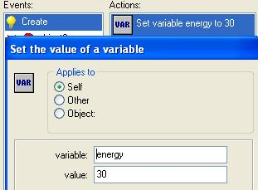

In the draw event, first the sprite is drawn
Draw Event:
at relative position (0,0) draw image -1 of sprite sprite0
Then a green rectangle with grey fill is drawn size 30
draw rectangle with relative vertices (0,35) and (30,41)
Then a green rectangle with green fill is drawn size = energy
draw rectangle with relative vertices (0,35) and (energy,41)

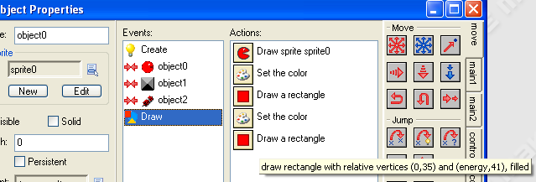
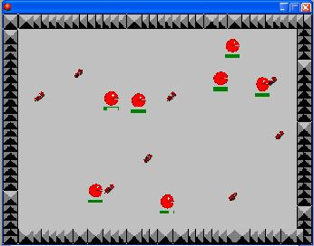

Inventory http://www.schoolgamemaker.rupert.id.au/howto.htm

The object "inventory" is used to keep track of diamonds, the variable "diamonds" is the number of diamonds collected
Create Event:
set variable diamonds to 0

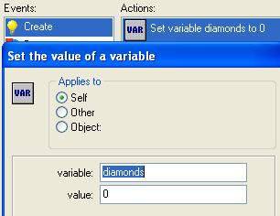

When you collide with the diamond it is destroyed and the inventory count increases by 1
Collision Event with object object1:
set variable inventory.diamonds relative to 1
for other object: destroy the instance

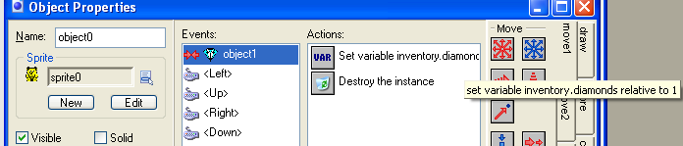
diamonds lives inside the inventory object, when referred to inside inventory, you can just call it diamonds, when referred from another object, you must use the full name inventory.diamonds

In the draw event for inventory, a box and the collected diamonds are drawn
Draw Event:
set the fill color to 16777215 and line color to 0
draw rectangle with vertices (0,0) and (200,40)
A white box is drawn

set variable i to 0
repeat next action (block) diamonds times
at position (20*i,0) draw image -1 of sprite sprite1
set variable i relative to 1
The sprite is drawn "diamonds" times
i is increased each time it is drawn, it is drawn further to the right each time as i increases

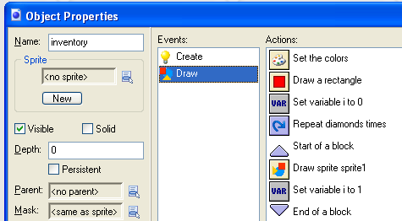

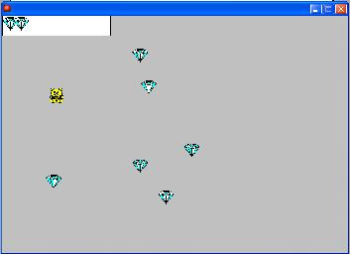

Inventory http://www.schoolgamemaker.rupert.id.au/howto.htm

Create Event:
set variable globalpress to 0
set variable globalpressx to 0
set variable globalpressy to 0
set variable depth to 1000

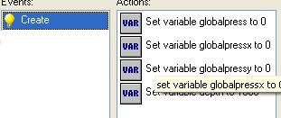

Mouse Event for Glob Left Pressed:
set variable globalpress to 1
set variable globalpressx to mouse_x
set variable globalpressy to mouse_y

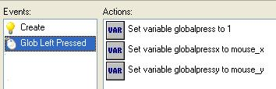

Mouse Event for Glob Left Released:
set variable globalpress to 0
if expression abs(controller.globalpressx-mouse_x)+ abs(controller.globalpressy-mouse_y) >6 is true
execute code:

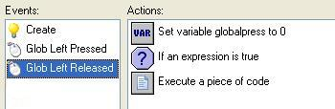

// workout if the box start is smaller than box end
if(globalpressx<mouse_x)
{
xsmall=globalpressx
xbig=mouse_x
}
else
{
xbig=globalpressx
xsmall=mouse_x
}
if(globalpressy<mouse_y)
{
ysmall=globalpressy
ybig=mouse_y
}
else
{
ybig=globalpressy
ysmall=mouse_y
}

with object0
{
selected=0 // deselect all objects
if (x>controller.xsmall &&x<controller.xbig && y>controller.ysmall &&y<controller.ybig)
selected=1
}

Draw Event:
if expression globalpress=1 is true
set the drawing color to 65280
draw rectangle with vertices (globalpressx,globalpressy) and (mouse_x,mouse_y), outline

