Some Pointers for DTP
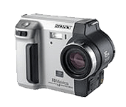
It is not a good idea to wrap text around both sides of a picture at once. If you do it becomes difficult to work out where you should read the next word. It is not a good idea to wrap text around both sides of a picture at once. If you do it becomes difficult to work out where you should read the next word. It is not a good idea to wrap text around both sides of a picture at once. If you do it becomes difficult to work out where you should read the next word.

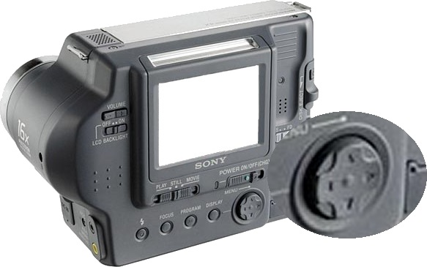
It’s much better to only wrap text around one side of a picture at a time. If you place a picture in-between two columns then there is no confusion as to where you should look to read the next word in the paragraph.

Or place the picture to the left of the column. Or place the picture to the left of the column. Or place the picture to the left of the column. Or place the picture to the left of the column. Or place the picture to the left of the column. Or place the picture to the left of the column. Or place the picture to the left of the column.

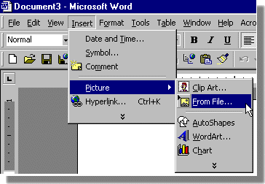

To insert a picture into a document select Insert | Picture | From File...

Select the picture you want to insert and press Insert

To wrap text around a picture. First select the picture, then select the text wrapping tool from Picture toolbar and choose the wrapping option that you wish to use. The wrapping choice that I have used for the picture of the rear of the digital camera is Edit Wrap Points. Wrap points tell word where to warp text when it touches the edge of a picture.
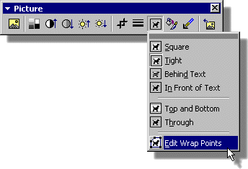

Editing the Wrap points
Allows you to wrap text
around a the outline of a
picture.

