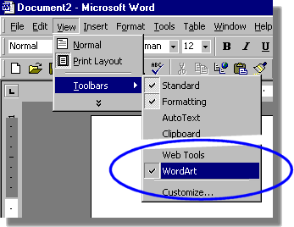

1

Word Art

1 Select View | Toolbars... WordArt
2

2 Select Insert WordArt
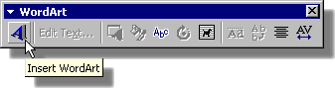

3 Select a style
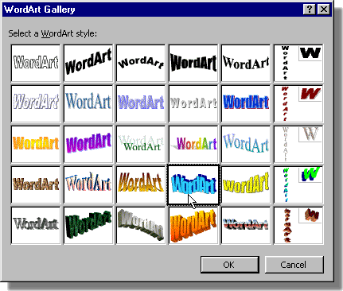
4 Select Font and Size
3

5 Type your text

6 Play with different effects

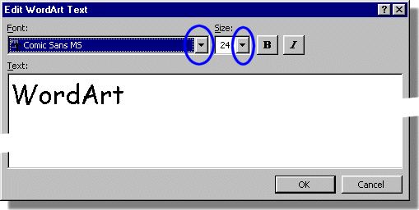

4

5

6

