

Information Desk
How to Publish files to your University Webpage
Info Sheet #19a
To publish files to your University Webpage you will use a File Transfer Protocol (FTP) program. The FTP program we recommend is Ws-FTP.
If you don’t have Ws-FTP installed, please see Information Sheet #19b for instructions on how to download and install Ws-FTP.

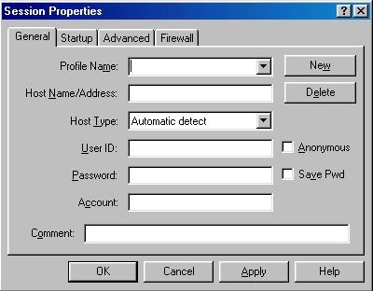
When you start Ws-FTP, the following window will be displayed:
The Profile Name can be any name you like, eg www or Web or Velorum
This must be the name of the server you are connecting to.
Ie. velorum.ballarat.edu.au
Your student number.
velorum.ballarat.edu.au
www
2312345
Your FTP password.
Note: This requires numbers & letters and is case sensitive.
- Click on the New button to delete any information that is currently occupying any of the fields.
- After you have filled in the appropriate fields, click OK.

Once you have connected, you will see the following window:
- On the left side is a list of files from your local system (C:\). You can change this by clicking on the ‘ChgDir’ button, and entering the directory of your choice.
- On the right side is a list of files on the remote system (Web server)
- You can move up a directory by double clicking on the green arrow  at the top of each window.
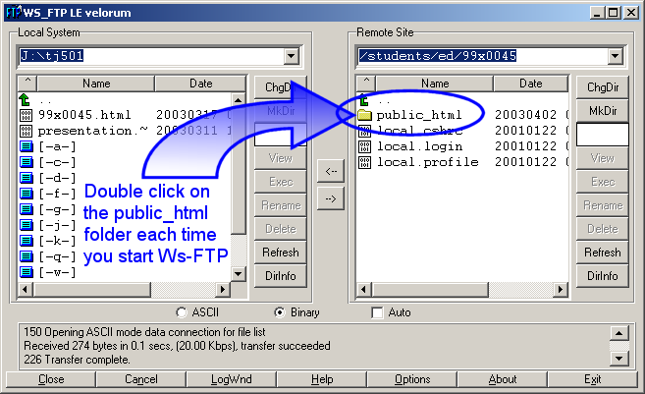

To Publish files from the Local system to the Web, select the file(s) you wish to publish and click the transfer button.

Eg. to publish the file ‘presentation.ppt’ to the Web
- Click on the file presentation.ppt
- Click on the button
- The file will now be visible in the remote site window, and will be on the Web.
Note: You should create a link from your home page to the presentation.ppt file, and then publish your new home page.
If you want to publish multiple files at one time click on the first file and shift + click on the last file in the list. You should see all the files you wish to publish highlighted in blue. Then click on the transfer button.

- Other information sheets are available from the Information Desk, Entry Level, Library Building

